# Requirements

## Functional requirements:

**Critical priority:**

1. As a product owner, I want to have an IT project management system, such that I can efficiently manage my projects.
2. As a project creator, I want to be able to create projects,
3. As a product owner, I want my system to have a GUI, such that the users could easily navigate through the system.
4. As a project creator, I want to be able to assign team members, so that there are people working on projects.

**High priority:**

1. As a project creator, I want to be able to assign roles to the team members so they know what responsibilities they have.
2. As a product owner, I want the GUI implemented with Java/JavaFx, such that it would be easy to modify.
3. As a product owner, I want to be able to mark the projects if they are started, not started or ended, such that the team members know what tasks are done and which are still to be worked on.
4. As a product owner, I want to be able to add or remove requirements, so that in case of a new or bad idea for the project, I can add or remove it from the list of requirements.
5. As a product owner, I want to have my requirements described as user stories in who, what, why template such that project is more understandable for the rest of the team.
6. As a product owner, I want to be able to approve or reject requirements, such that the team members do not waste their time working on the requirements which are not going to be useful for the project.
7. As a scrum master, I want each task to contain all information (Requirement ID, task ID, title, time estimation, deadline, responsible team member, status, hours spent and by who) such that I can track their progress more effectively.
8. As a team member, I want to be able to access the system without having to login, because the system can only be used by one team member at a time.
9. As a team member, I want to be able to give a status report daily to the scrum master, about which task I am working on and if it has ended or not, because he needs this information to be able to manage the requirements.
10. As a scrum master, I want to see each team member responsible for a specific requirement/task, so I know who is responsible if it falls behind schedule.
11. As a scrum master, I want to verify the status of each task/requirement in the form of: started, not started, finished; such that I can send this information to the product owner for further verification.
12. As a project creator, I want to have the possibility to change the roles of the team members, so that they could work on tasks suitable for them.

**Low priority:**

1. As a product owner, I want to have a website for the customers, so that they can check the status of their ordered projects.
2. As a product owner, I want to be able to search information regarding the projects by ID, responsible team members, deadlines, such that I can have an overview of the progress on a current project.
3. As a customer I want to be able to view my project on a website, so that I can easily access it.
4. As a customer, I want to be able to have all the information displayed about my project (Description, Requirements and their status), so that I can stay updated on its progress.
5. As a project creator, I want to be able to add/remove new team members in case the team is not able to cover all the tasks. When it comes to removing participants, this should take place, if necessary, so that the work flow of others is not compromised.

## Non-functional Requirements:

1. As a customer, I want the system and website to be easy to use.

The system must be compatible with each device and be able to run on any

operating system.

The system must not have a response delay of more than 1.5 seconds in more than 90% of the cases.

The system must be updated periodically and checked in case of errors.

# Use Case Diagram

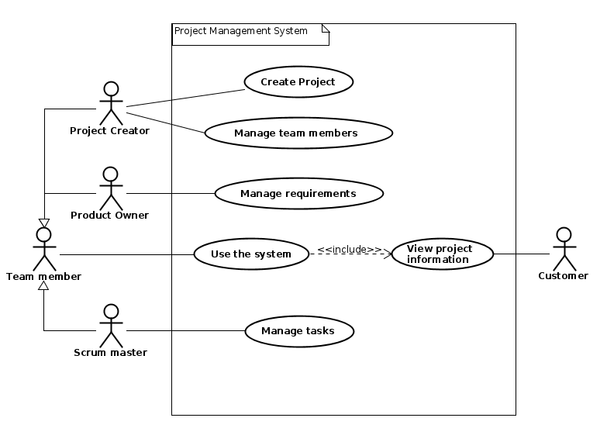

# 

# Use Case Descriptions

| **Use case** | **Create Project** |
| --- | --- |
| **Summary** | Creating a project in which the customer can see information |
| **Actor** | Project Creator |
| **Precondition** | There has to be a Project Creator and a potential name for the project |
| **Postcondition** | A project is created, therefore, requirements, tasks and other work can be completed |
| **Base sequence** | 1. Open system 2. Create a project 3. Choose the name of the project 4. Save project |
| **Exception sequence** |  |
| **Note** | This use case covers requirements 1, 2 |

| **Use case** | **Manage Team Members** |
| --- | --- |
| **Summary** | Adding/removing Team Members or assigning (new) roles to those |
| **Actor** | Project Creator |
| **Precondition** | A project has to be created |
| **Postcondition** | The project is better organized so that there are no disruptions to completing the requirements for it |
| **Base sequence** | 1. Open system 2. Search for a project 3. Add/Remove Team Members 4. Assign/Change roles to/of each Team Member 5. In case of unpredicted delays or reasons that interfere with getting the tasks done, redo either step 3 or 4 6. Save project 7. Start working on the project |
| **Exception sequence** | If there is no project created, then there can not be any management of the Team Members done. |
| **Note** | This use case covers requirements 4, 5, 16, 21 |

| **Use case** | **Manage requirements** |
| --- | --- |
| **Summary** | Add or remove requirements, so that in case of a new or bad idea for the project, I can add or remove it from the list of requirements. |
| **Actor** | Product Owner |
| **Precondition** | A project should already be created in the system. |
| **Postcondition** | The requirements are now better suited for the project. |
| **Base sequence** | 1. Open System. 2. Open Project. 3. Open List of Requirements. 4. Add or Remove Requirement/s. 5. Give Requirement/s an ID. 6. Save List of Requirements. 7. Save Project. |
| **Exception sequence** |  |
| **Note** | This use case covers requirements 8, 10 |

| **Use case** | **Use the System** |
| --- | --- |
| **Summary** | Update tasks that a team member has worked on, and find project information. |
| **Actor** | Team member |
| **Precondition** | A project has to be created in the system. |
| **Postcondition** | Tasks have been updated, and team members have found required information. |
| **Base sequence** | 1. Open system 2. Search for a project 3. If project not found go back to step 2 4. Click on project 5. For updating tasks go to 5 6. Finding information about a project go to 10 7. Click on tasks 8. Click on task you need to update 9. Enter amount of hours spent and what date 10. Save task 11. If more tasks need to be updated go to step 2 12. Read information about project 13. Click on requirements to find information about requirements 14. Click on tasks to find information about requirements |
| **Exception sequence** |  |
| **Note** | If there are no projects in the system, team members will not be able to do anything in the system.  This use case covers requirements 3, 6, 9, 12, 13, 18 |

| **Use case** | **View project information** |
| --- | --- |
| **Summary** | Customer finds information regarding the ordered project. |
| **Actor** | Customer |
| **Precondition** | Work has started on the customers ordered project. |
| **Postcondition** | Customer knows about progress on the ordered project. |
| **Base sequence** | 1. Enter provided web address 2. Search for specific project 3. Wrong search term, repeat step 2. 4. Click on project 5. For information about requirements click on requirements 6. For information about tasks click on tasks |
| **Exception sequence** |  |
| **Note** | Website has to be regularly updated by the development team in order for the customer to see the latest information regarding their projects.  This use case covers requirements 17, 19, 20 |

| **Use case** | **Manage Tasks** |
| --- | --- |
| **Summary** | Documenting the status of each task in form of - “Started”, “Not started”, “Finished”, as well as reporting the status of requirement information further to the Product owner. |
| **Actor** | Scrum master |
| **Precondition** | Projects requirements have to be identified and the work on the tasks has to begin. |
| **Postcondition** | A requirement has been updated from “Not started” status to  "Started" status or “Finished” status. A sent documentation to the Product owner about the status information for further approval. |
| **Base sequence** | 1. Start the system 2. Search for the requirements and tasks by their ID to display necessary information like description, time estimation, deadlines, responsible team members, how many hours spent working on it and who is responsible. 3. Follow-up and check the status of each specific requirement. 4. Mark each requirement: 5. If the work process on the requirement has begun, then mark it as “Started”. 6. If the work process on the requirement has not begun yet, then mark it as “Not started”. 7. If the work process on the requirement has been finished, then mark it as “Finished” 8. Send the report to the Product owner for further approval |
| **Exception sequence** | If the team members are not meeting the deadlines go to step 5 in a base sequence. |
| **Note** | This use case covers requirements 7, 11, 14, 15 |

Relation between requirements and use cases

| **Use case** | **Covered requirements** |
| --- | --- |
| *Create project* | **1, 2** |
| *Manage team members* | **4, 5, 16, 21** |
| *Manage requirements* | **8, 10** |
| *Use the system* | **3, 6, 9, 12, 13, 18** |
| *View project information* | **17, 19, 20** |
| *Manage tasks* | **7, 11, 14, 15** |

| **Requirement** | **Related use case** |
| --- | --- |
| **1** | Create project |
| **2** | Create project |
| **3** | Use the system |
| **4** | Manage team members |
| **5** | Manage team members |
| **6** | Use the system |
| **7** | Manage tasks |
| **8** | Manage requirements |
| **9** | Use the system |
| **10** | Manage requirements |
| **11** | Manage tasks |
| **12** | Use the system |
| **13** | Use the system |
| **14** | Manage tasks |
| **15** | Manage tasks |
| **16** | Manage team members |
| **17** | View project information |
| **18** | Use the system |
| **19** | View project information |
| **20** | View project information |
| **21** | Manage team members |